**CHANDRIKA WOMEN AND YOUTH FOUNDATION**



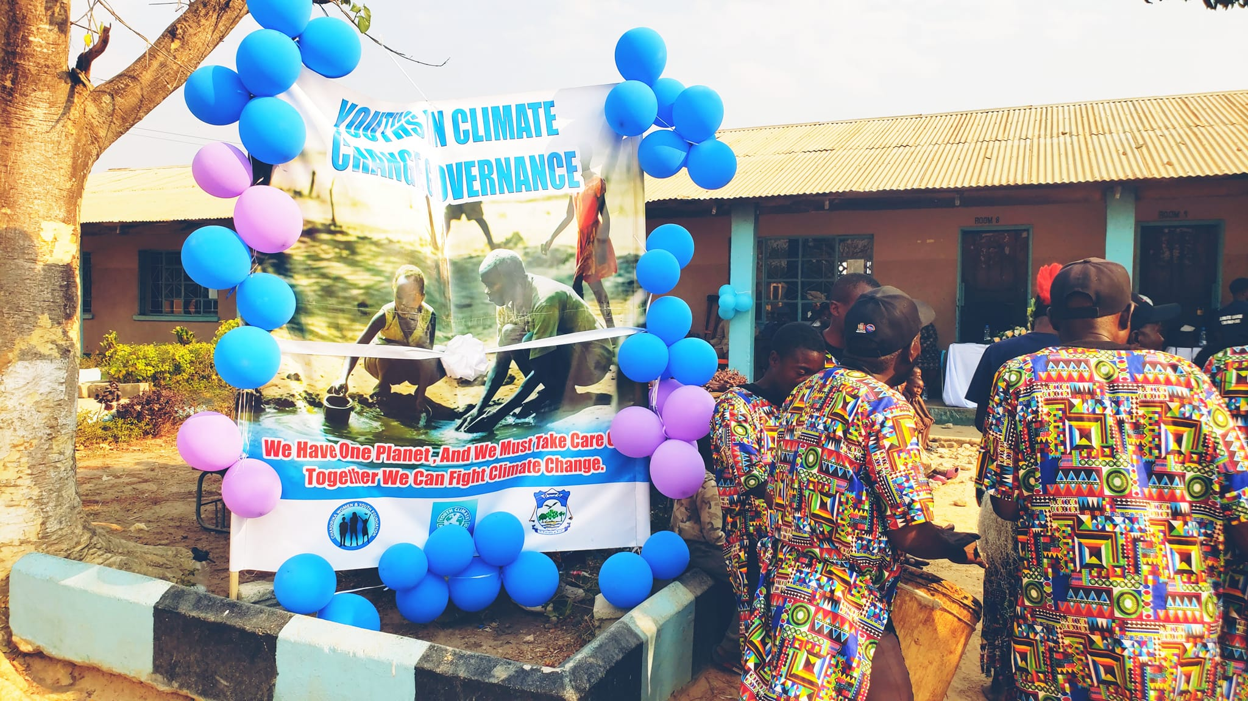

**REPORT ON COMMUNITY AWARENESS ON CLIMATE CHANGE LAUNCH AT MUCHINKA COMBINED SCHOOL IN CHILYAPA WARD**

**Introduction**

Chandrika Women and Youth Foundation (CWYF) is privileged to be among the organizations that was funded by the Council with support from Bloomberg Philanthropies under the youth climate action fund, to conduct activities on climate change in Mansa District of Luapula Province.

In kick-starting the activities on climate change, Chandrika WYF, launched the ‘**Youth in Climate Change Governance Project’** at Muchinka Combined School on the 29th of August 2024. The event was graced by His Worship the Mayor for Mansa District, Mr. Njikho Musuku, who was accompanied by the Chilyapa and Misakalala Ward Councillors respectively. Two Village headpersons, headman Musomali and headman Chimupeni were also among the people who attended the event.

In attendance were 105 males and 123 females, comprising of women, men, youths and children, thus the total attendance during the Community Awareness Campaign on issues of Climate Change in Chilyapa Ward was 228. This report will therefore highlight some of the activities that were conducted during the launch of the tree planting exercise and community awareness activities on climate change held at Muchinka Combined School.

**Objective**

To launch the program for Community Awareness on Climate Change.

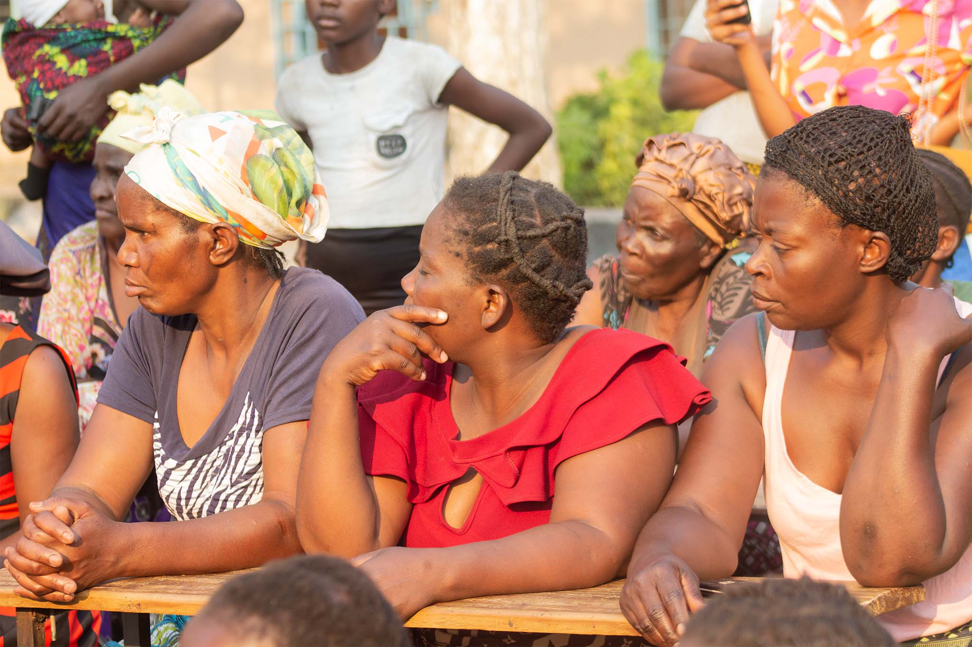

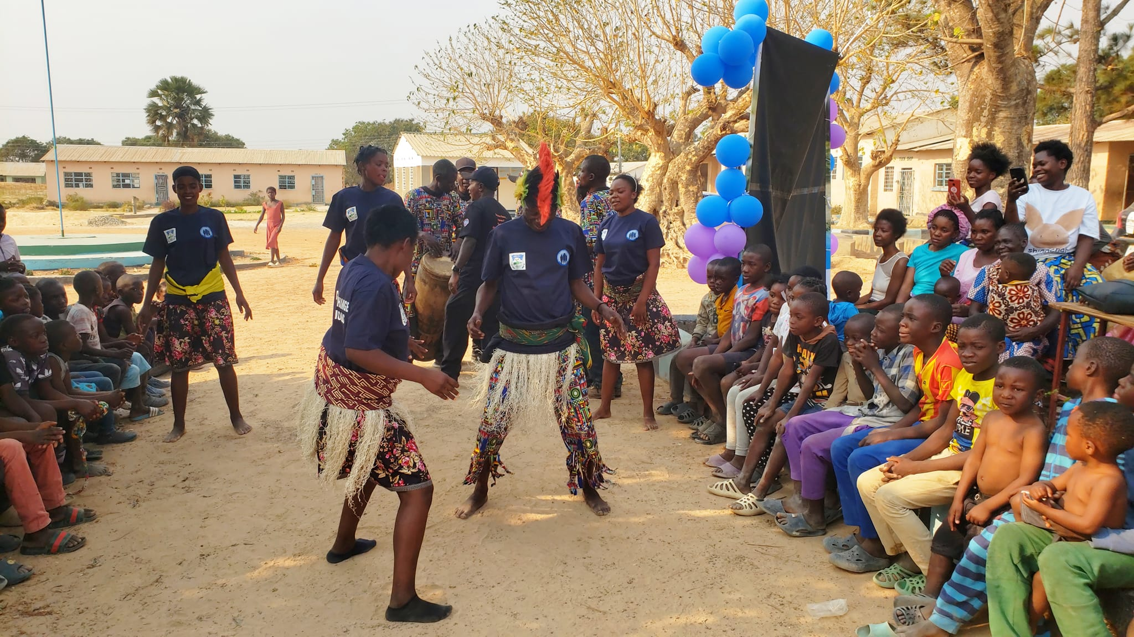The program began at 13:30. A diverse group of people arrived, including men, women, youth, and children, and were entertained by the drama group 'Chili Kuli Iwe'.

***Drama Performance by “Chili Kuli Iwe”***

The national anthem was sung. Thereafter, the Manager of Muchinka Combined School welcomed everyone present and invited Mrs. Priscilla Mwansa, Executive Director of Chandrika Women and Youth Foundation (CWYF) to come give her welcoming remarks.

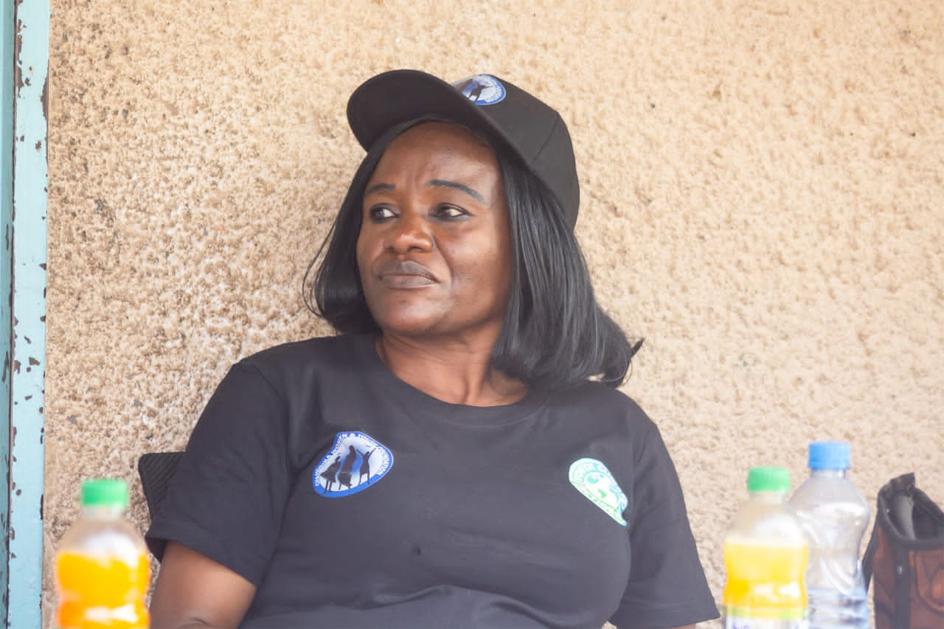**CWYF Welcoming Remarks**

Mrs. Priscilla Chama Mwansa the Executive Director for Chandrika Women and Youth Foundation (CWYF), welcomed everyone present and explained the purpose of the gathering and the project in detail. In her remarks she explained that climate change was affecting everyone including the people of Luapula Province. She asked the audience if they had noticed Zambia's current drought, which is unprecedented. This is attributed to climate change.

She further went on to explain that in a bid to reduce and mitigate the effects of climate change Bloomberg working in collaboration with Mansa Municipal Council came up with the initiative of the youth climate action fund which is aimed at empowering youth clubs, such as Amapange Yansaka and many others in Mansa District to drive positive change. Climate change is partly caused by widespread deforestation. To combat this, trees will be planted in selected Schools and Communities and this will be accompanied by Climate Change Awareness Sensitizations. Chandrika Women and Youth Foundation is targeting three Wards of Mansa District, namely; Chilyapa, Namwendwe and Mulenshi Wards and two Schools in each Ward.

**Chilyapa Ward Councillor**

Mr. Samuel Mwansa the Ward Councillor for Chilyapa welcomed everyone and shared a traditional Bemba proverb, “Imiti Ikula Impanga,” meaning “Young Children are tomorrow’s adults ” or “Young children are the future leaders ” He expressed his delight at the large number of children present, recognizing the crucial role they play in shaping the future of our village and nation.

The children present were encouraged to pay close attention and share what they had learnt with their parents, especially those who had been unable to attend. Mr. Mwansa emphasized responsible tree management and conservation, encouraging parents to conserve our natural resources. “We all have a role to play."

**The Mansa Mayor**

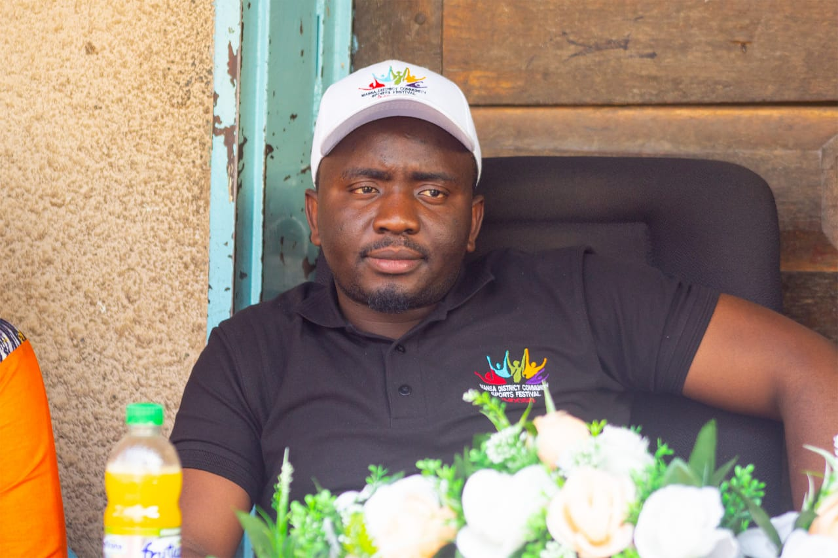The Mayor Mr. Njikho Musuku of Mansa extended a warm welcome to all in attendance and

acknowledged the presence of several esteemed guests, including the Misakalala Councillor, CWYF Executive Director who spearheaded the event, Muchinka Combined School Manager, Chilyapa Councillor Mr. Mwansa, and the Village Headman.

He posed a series of thought-provoking questions to the audience:

* How many of you use a brazier for cooking?
* How many use a stove?
* Don't we all experience frequent power outages?
* How many of you are fed up with school and plan to become charcoal burners or tree cutters?
* On the other hand, how many are eager to learn about planting trees?
* And how many aspire to have multiple mango or fruit trees in your homes?

These questions sparked reflection and set the stage for an engaging discussion.

The mayor further highlighted a practical example of climate change, citing the persistent load shedding and dwindling water levels in our local river, as evident in our daily lives. He acknowledged the efforts of the Council in securing funding from South Africa, which enabled the gathering and planning for future initiatives.

Previously, Mr. Chitalu Chilufya had emphasized the gravity of climate change, warning that Muchinka water sources are finite. The mayor assured that the council would provide a water tank for the school, ensuring a steady supply. He stressed the importance of taking climate change seriously and working towards making load shedding a thing of the past, emphasizing that we have the power to create a sustainable future.

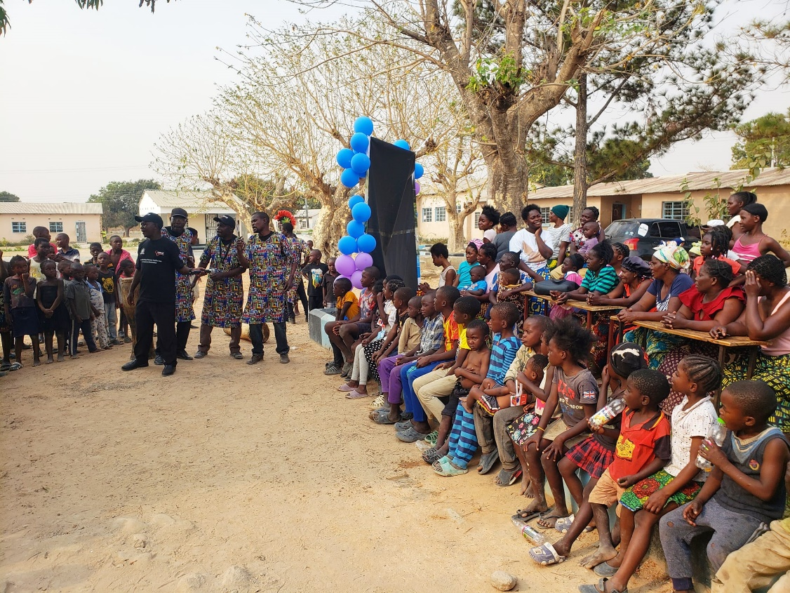**Sensitizations on Climate Change**

**Drama Performance by “Chili Kuli Iwe”**

*A simplified and practical example of the effects of climate change in our communities.*

Mr. Bornface urged everyone to be mindful when disposing of trash, emphasizing that bins and pits are provided for a reason, namely to keep our drains free of waste. He also recommended that the number of public bins in town should be increased to achieve a trash-free environment. Following his remarks, Mr. Bornface invited the audience to pose questions regarding the topics discussed and the drama that had just concluded.

The questions were as follows:

1. “What kinds of trees can we plant, trees that don't need a lot of water?”
2. “If we have a small yard and the house takes up most of the space, how can we fit in a tree without it getting too big and damaging the house?"
3. “We're used to cutting down trees for charcoal because of the power outages. How are we supposed to survive if we can't cut down trees? How will we cook since gas cylinders are expensive? What will you do to help us?"

**Solutions:**

1. Plant fruit trees like mangoes or avocados. That way, one can enjoy the shade and eat the fruits too.
2. When planting trees in small yards, choose spots near the wall fence, away from the house. This way, the trees won't damage your home when they grow big."
3. Councillor Misakalala took the floor and encouraged everyone to start planting avocado and mango trees. One can sell the seedlings and make money. Those more fortunate can use gas cylinders from places like Oryx. We're all affected by climate change, so we must work together to solve this problem. Planting millet and cassava is a good idea too - they don't need much water and are healthy foods.

The Ward for Chilyapa said that it was not illegal to cut down trees or use charcoal, but emphasized the importance of balance. He stated that for every tree cut down, a new one should be planted to replace it. He urged people not to cut down all the trees, but only those suitable for charcoal, such as Mubanga trees, and to leave the other trees alone to play their role in the ecosystem.

Mr. Jones Chisanga, the Project Manager, also addressed the gathering. He pointed out that the problem of excessive tree cutting was evident, and reiterated the solution of replacing each cut-down tree. He emphasized that sustainable development involves considering future generations and setting a good example for today's children to follow.

In response to how expensive gas cylinders are, he mentioned that a youth club would be teaching alternative cooking fuels, such as making charcoal or energy-rich substances from groundnut shells, leaves and many other sources. He urged parents to support this initiative, so that children could understand the importance of these efforts.

**Cutting of the Ribbon & Tree Planting**

The Mansa Mayor addressed the gathering before cutting the ribbon, saying, "Today, August 29th, on behalf of the Chandrika Women and Youth Foundation and the rest of the team, we are officially launching the tree planting initiative at Muchinka Combined School."

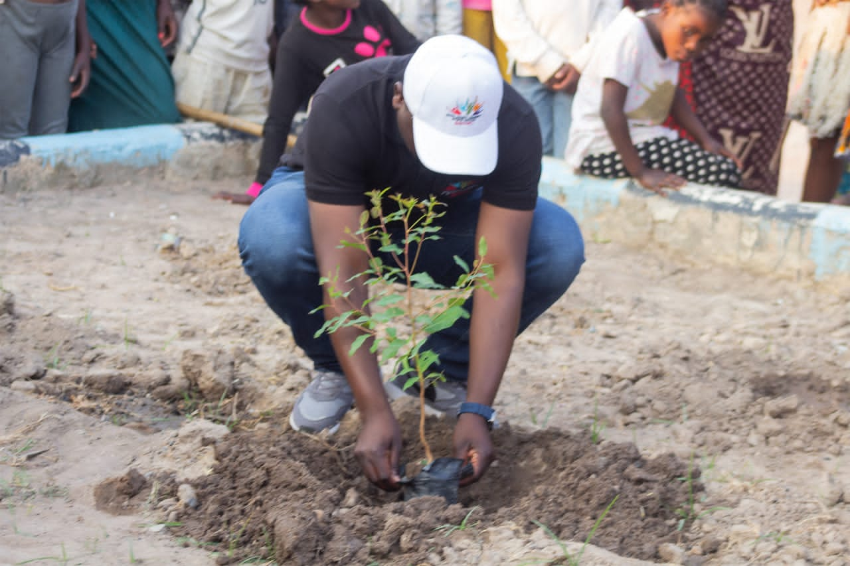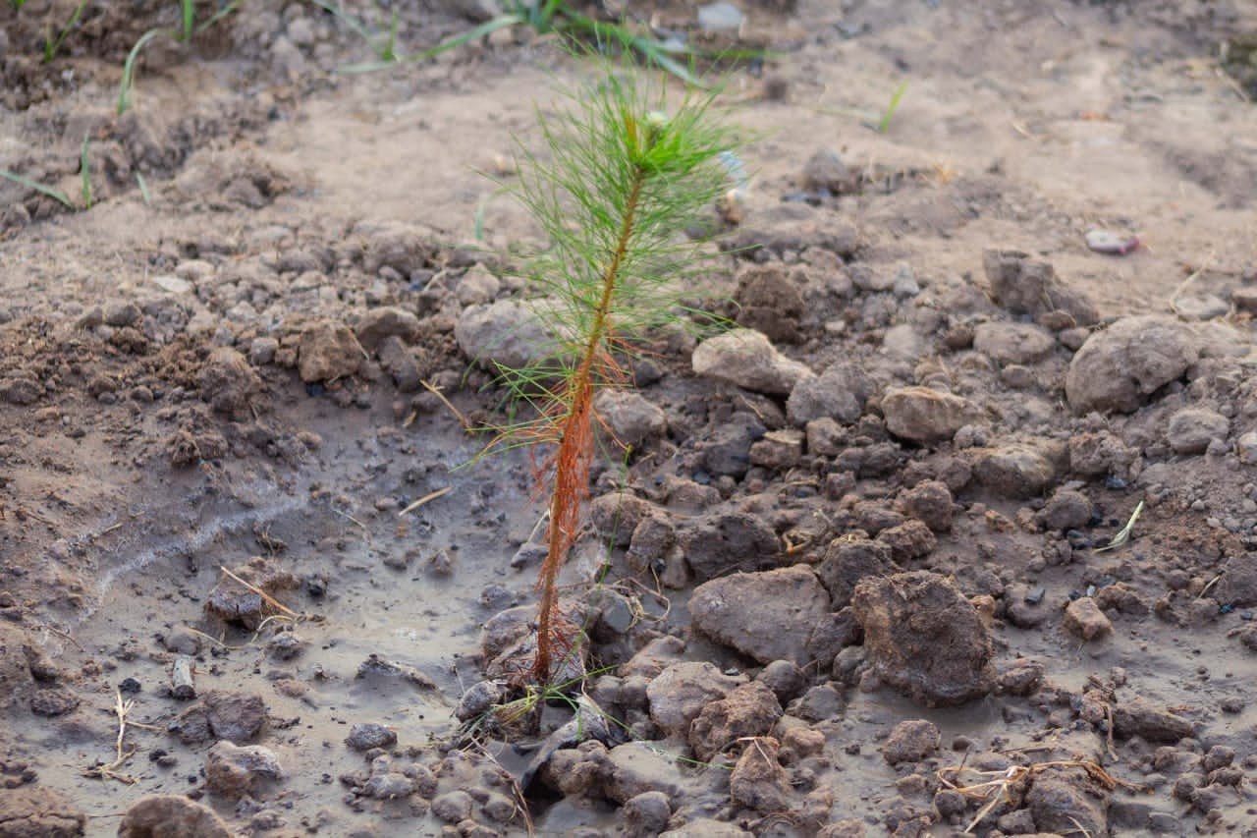The audience applauded, and then the mayor, accompanied by others, proceeded to a designated spot on the school premises. The mayor planted the first tree, followed by the Chilyapa councillor, the Muchinka Combined School Manager, the Misakalala Ward councillor, and finally the CWYF Executive director.

The event concluded with a vote of thanks by the Village Headperson, the singing of the national anthem, and a closing prayer by a community member.

**Analysis**

The program demonstrated a positive step towards promoting environmental conservation and community engagement. With continued collaboration and expansion, the initiative has the potential to make a meaningful impact.

**Short-term Outcomes:**

* Raised awareness about environmental conservation
* Tree planting at Muchinka Combined School
* Community engagement and collective action

**Long-term Outcomes:**

* Positive environmental impact (reduced carbon emissions, improved air quality, biodiversity)
* Behavioural change (adopting sustainable practices)
* Community ownership and responsibility
* Potential replication in other schools and communities

**Conclusion**

This program was an important step towards helping the environment and making our community more sustainable. Planting trees at Muchinka Combined School showed that when we work together, we can make a big difference. The event helped people understand why taking care of the environment is crucial and encouraged them to take action. By involving young people and the community, we can make sure that this effort will have a lasting impact. As the trees grow, so will our commitment to protecting the environment."